# Why Java 8 is important:

Functional features are introduced:

Lambdas

Streams

Optionals.

Simplify the concurrency operations.

## Functional programming:

Embrace creating immutable objects.

Concise and readable code.

Uses functions/methods as first class citizens.

Ex: Function<String, String> addSomeString = (name) -> name.toUpperCase().concat(“default”)

## Imperative vs Declarative Programming:

### Imperative

Focus on how to perform the operation.

Embraces object mutability.

Lists steps on how to achieve an objective.

Used in classic OOP.

### Declarative:

Focus on what is the result needed.

Embraces object immutability.

Analogous to SQL.

Uses the library functions and part of functional programming.

## Lambda Expression:

Equivalent to a function without name.

Anonymous function.

Can be assigned to a variable.

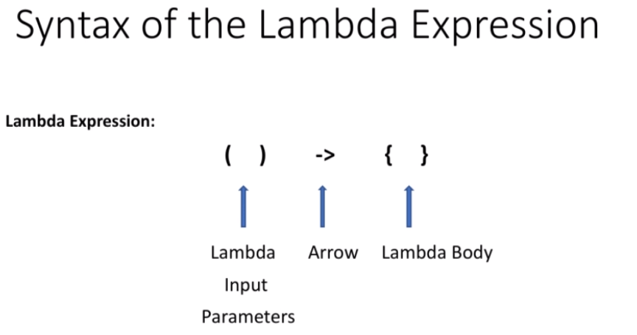

### Usages of Lambda:

Mainly used to implement functional interfaces.(SAM- Single Abstract Method interfaces).

Interface with one abstract method are known as functional interface. They are annotated with

@FunctionalInterface.

Existing are Runnable and Comparator.

Ex: @FunctionalInterface

Public interface Comparator<T>{

Public int compare(T o1, To2);

}

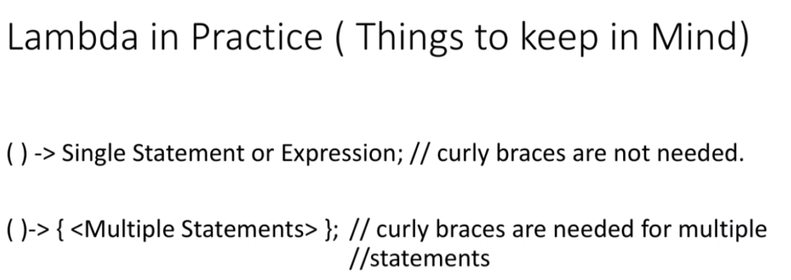

**********************************************************************************

## Functional Interfaces:

Any interface that has exactly one abstract method. SAM(Single Abstract Method).

@FunctionalInterface—Mandates the interface to have only one abstract method.

### New functional interfaces in java 8:

* Consumer
* Predicate
* Function
* Supplier

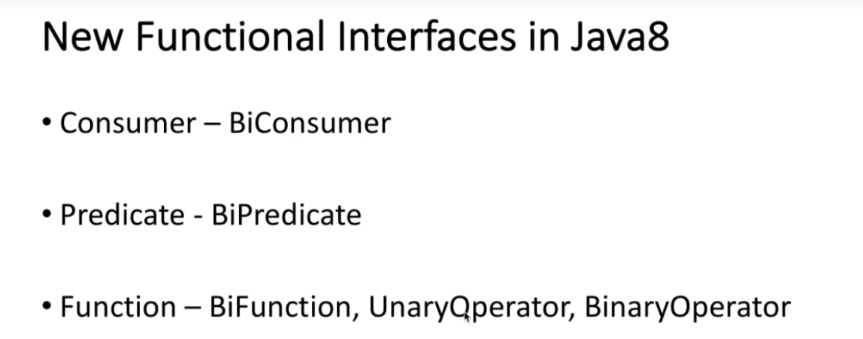

## Consumer:

One method ‘accept’ which accepts one input parameter.

Consumer chaining can be done with ‘AndThen’ refer the code example.

### Bi-Consumer:

‘accept’ parameter accepts two inputs.\

Refer code for details.

Can be used based on requirement nothing related to performance over Consumer.

## Predicate:

‘test’ method that returns Boolean for one input parameter.

‘and’,’or’,’negate’ methods are also present.

### BiPredicate:

‘test’ accepts two inputs and return Boolean.

### Function:

Coding a piece of logic, assigning to a variable and passing it around the application.

2 methods ‘andThen’ & ‘compose’. ‘compose’ will execute the inner function first and then the outer function.

### UnaryOperator:

Usecases, where input & output are of same type UnaryOperator instead of Function.

### BinaryOperator:

Operates on two inputs and produces one output.

Used in cases where inputs and outputs are of same type.

Minby and maxby are the two methods.

## Supplier:

‘get’ method

**********************************************************************************

## Method Reference:

Purpose is to simplify the implementation of functional interface.

#### Syntax:

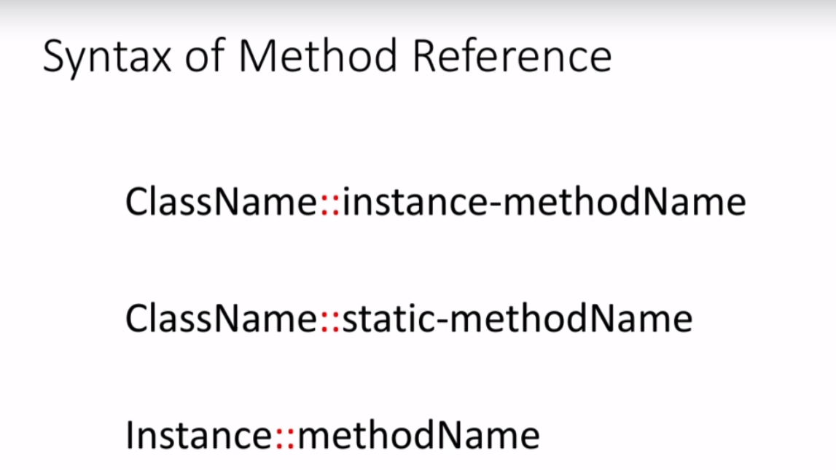

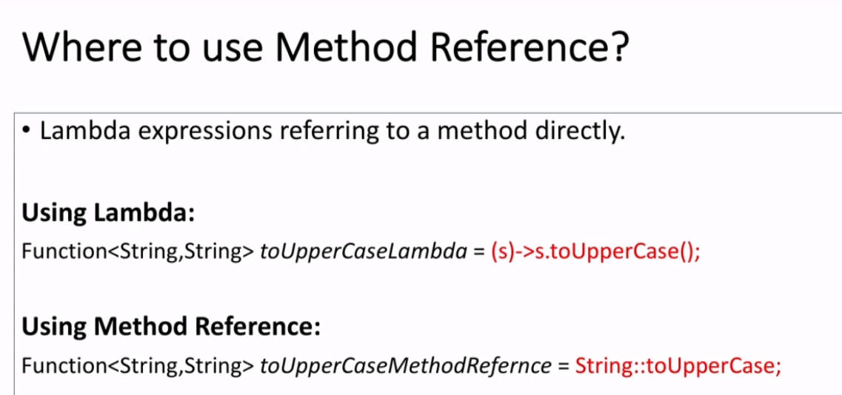

### Refactor Lambda Expression to Method Reference:

Refactor the predicate to methods.

### Constructor Reference:

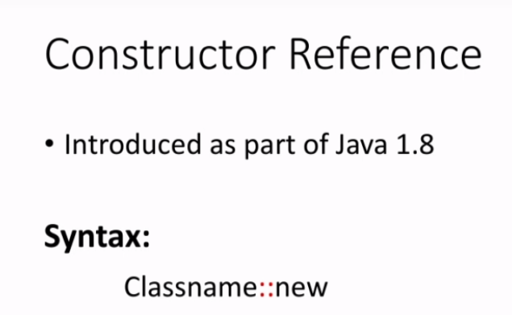

## Lambdas and Local Variables:

## Effectively Final:

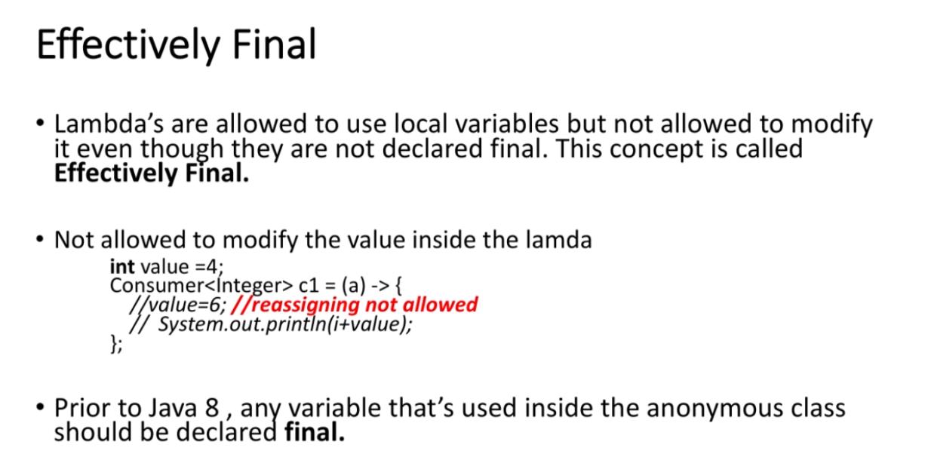

## Streams API:

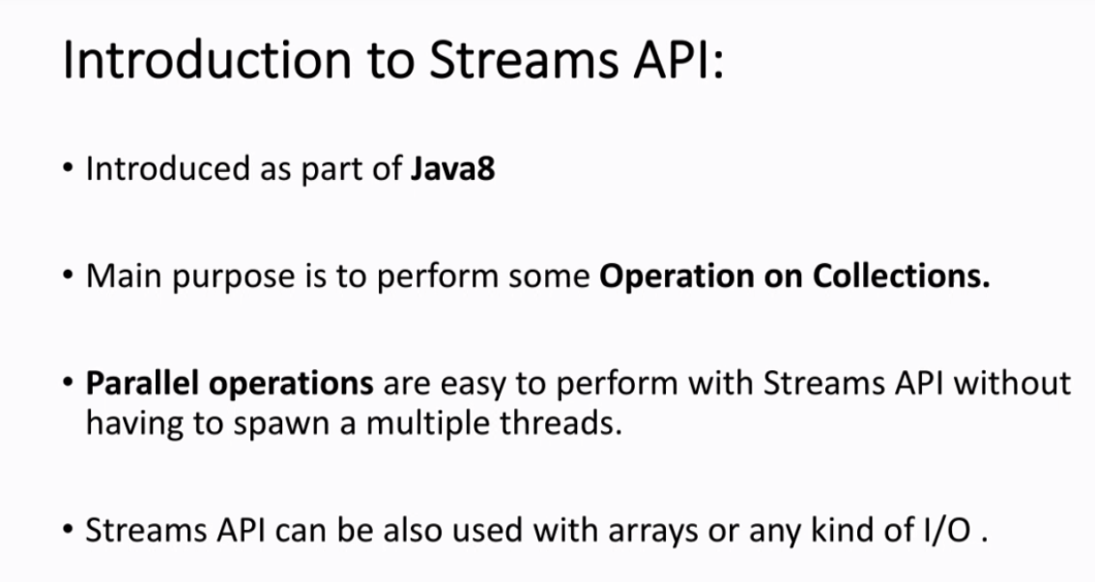

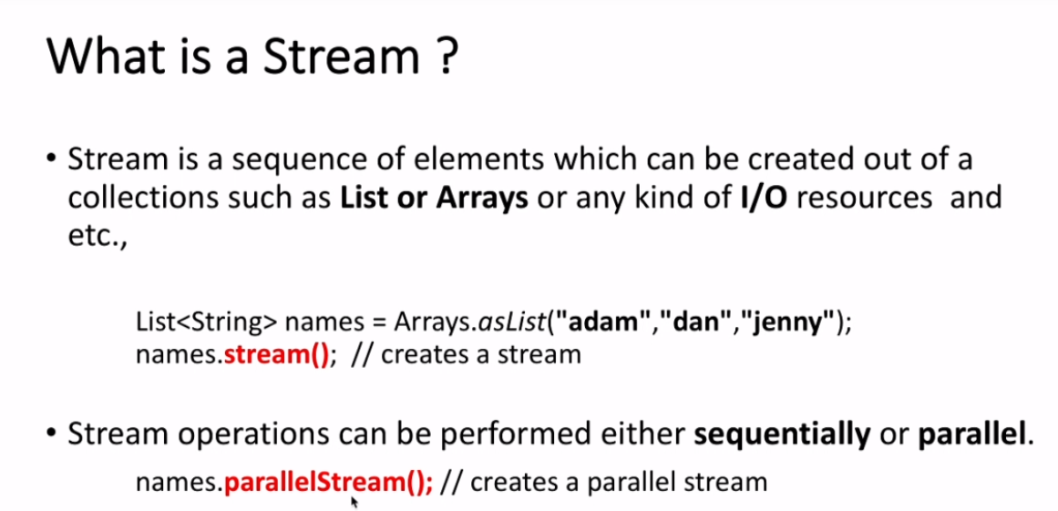

### How Stream API Works:

The operations that happens between the stream method and collect method are known as **Intermediate Operations**. Each operation returns a Stream.

Terminal Operations: collect. The operation in which stream is converted to collection. It starts the pipeline, so if this operation is not provided the total operation won’t happen . Streams are lazy, no intermediate operation is triggered until the terminal operation.

## Collections & Streams:

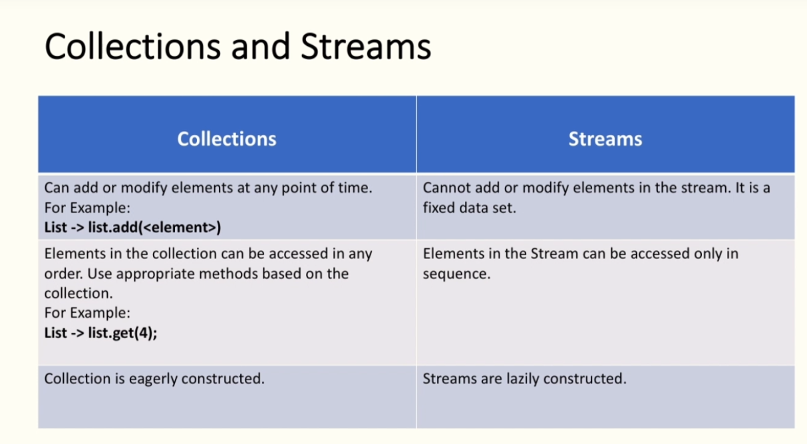

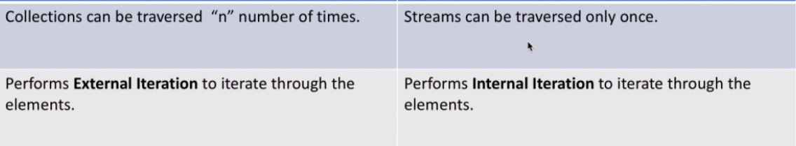

### Stream API: map()

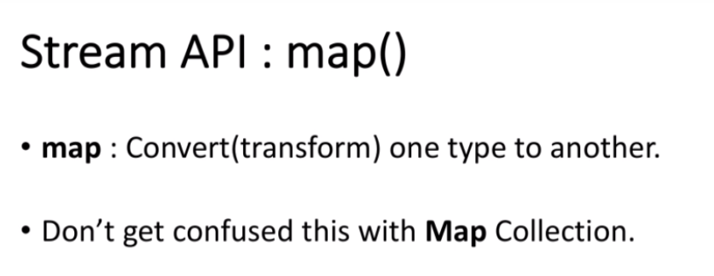

### Stream API: flatMap()

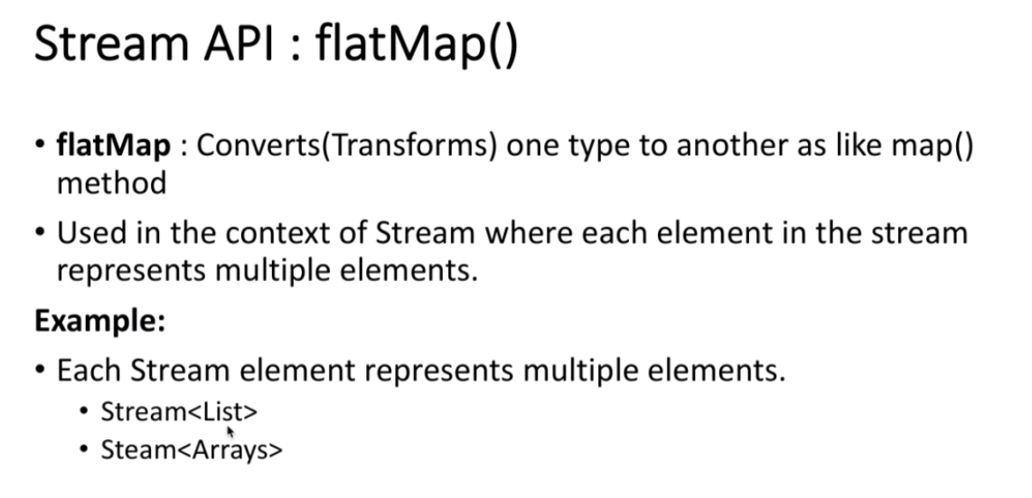

### Stream API: more functions

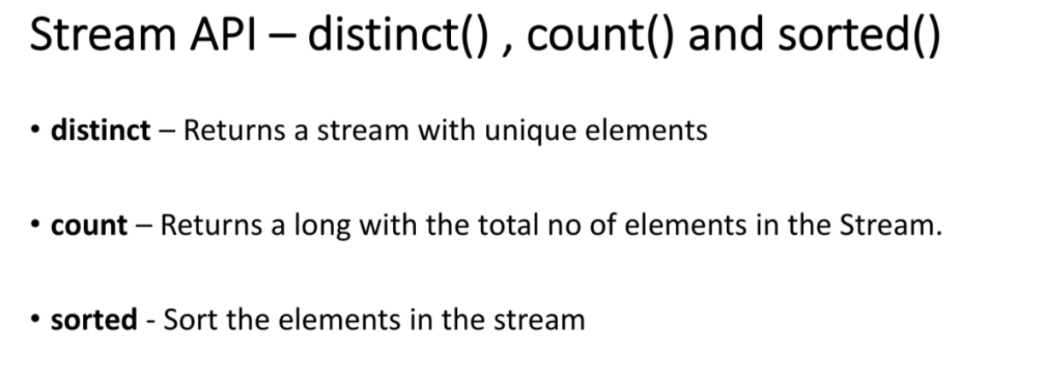

### Stream API: filter()

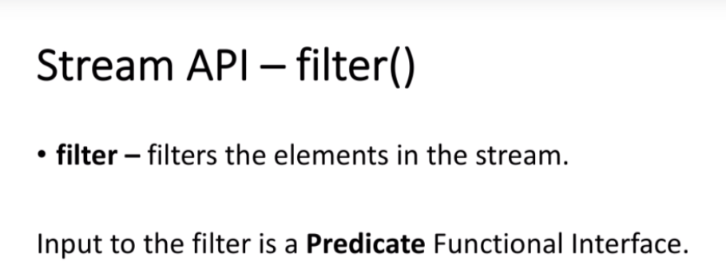

### Stream API: reduce(),map(),min(),max

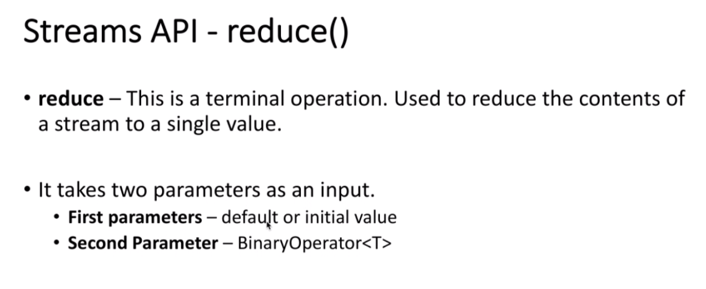

### Stream API: limit(),skip()

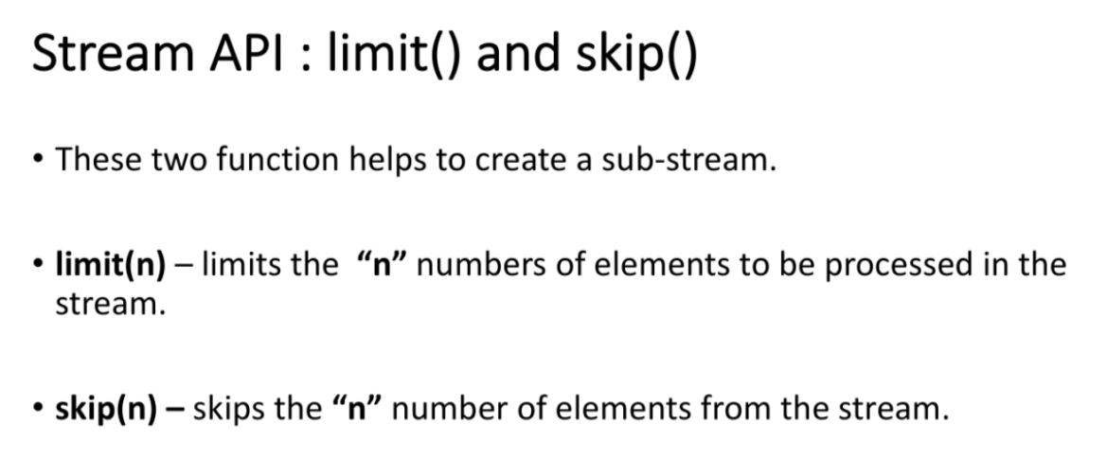

### Stream API: allMatch(),anyMatch(),noneMatch()

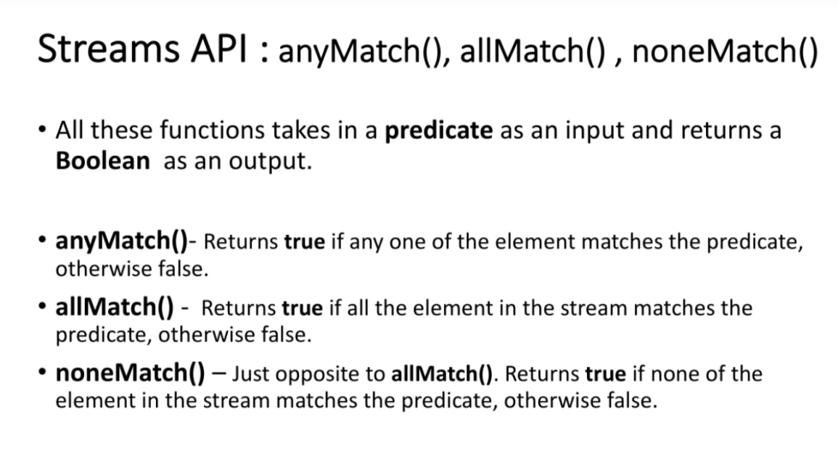

### Stream API: findFirst(), findAny()

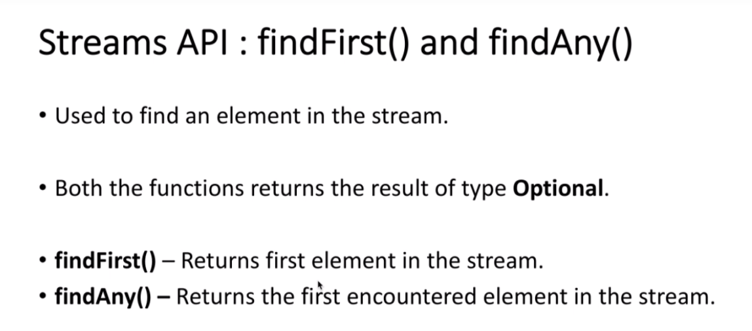

### Stream API: short circuiting

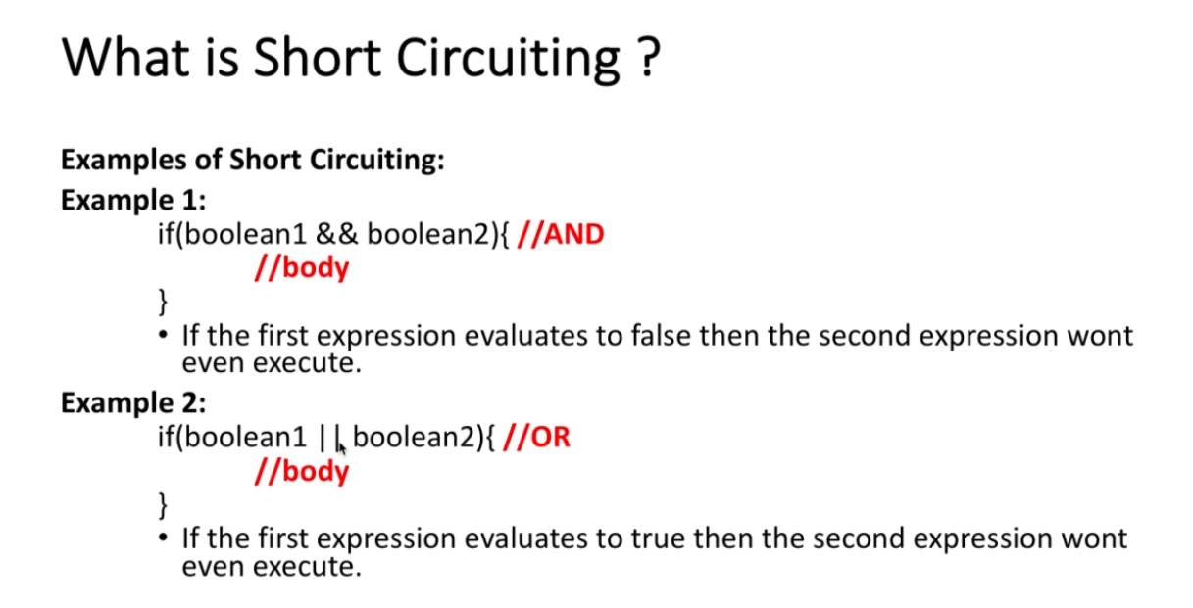’

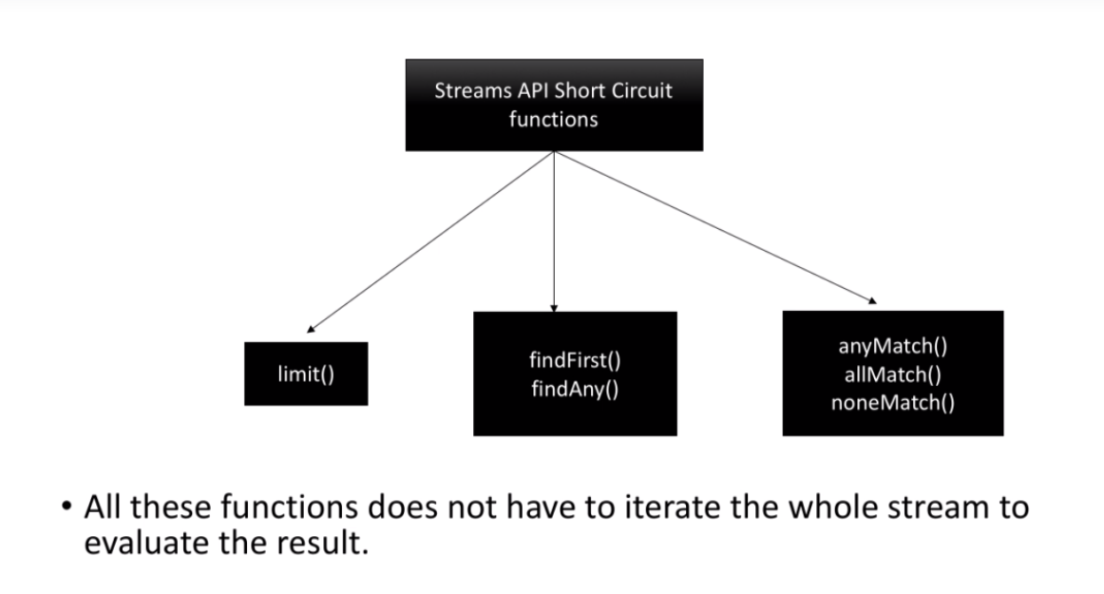

### Stream API: of(), iterate(), generate()

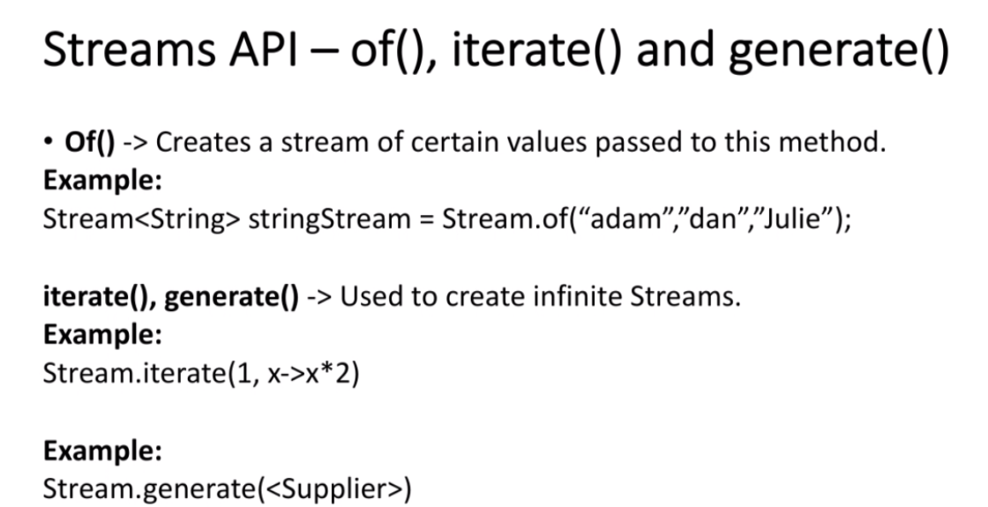

## Numeric Streams:

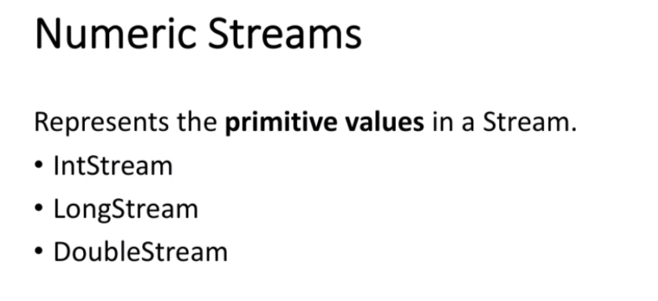

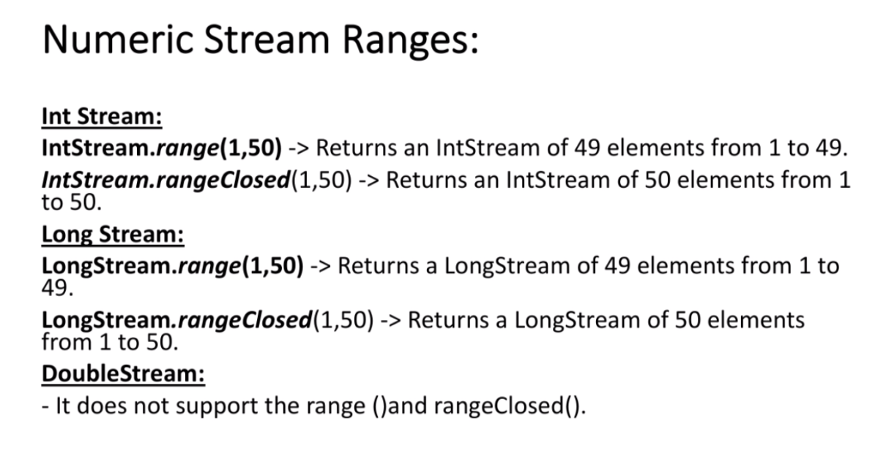

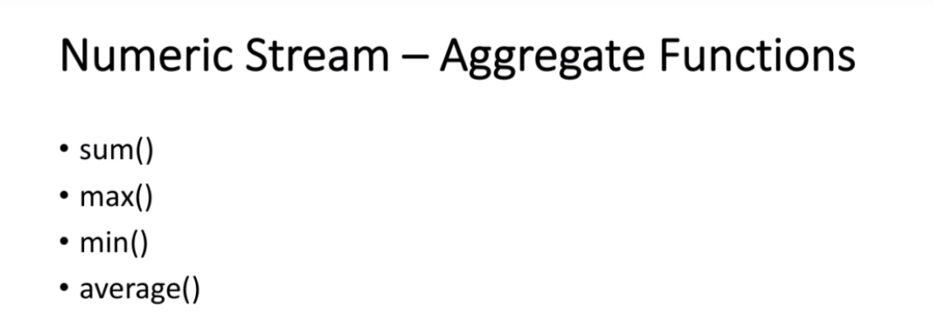

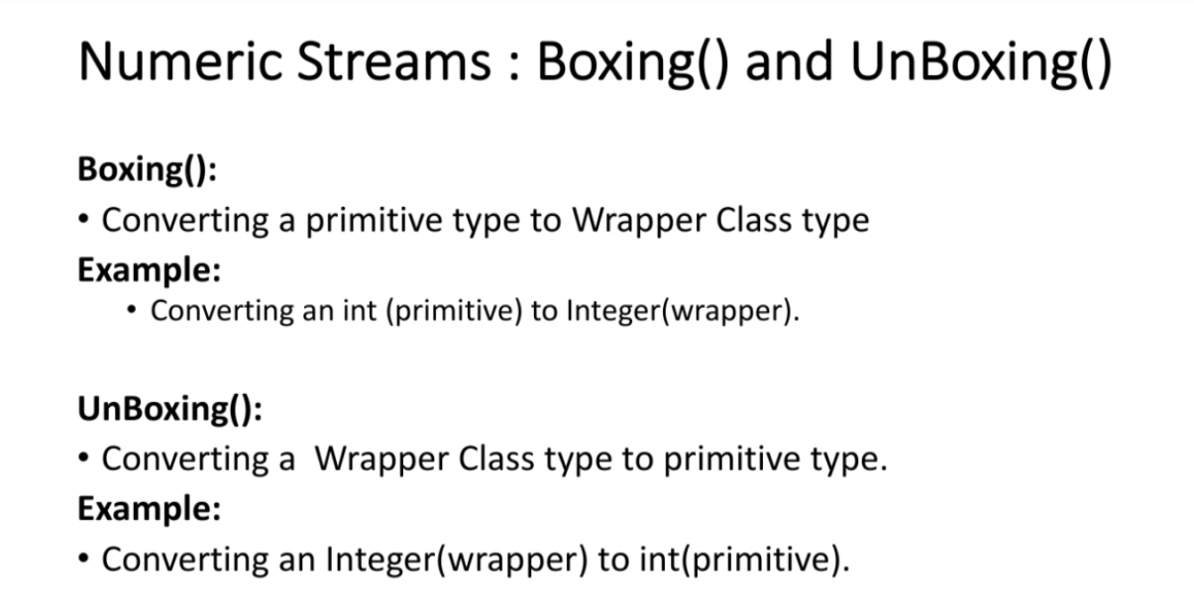

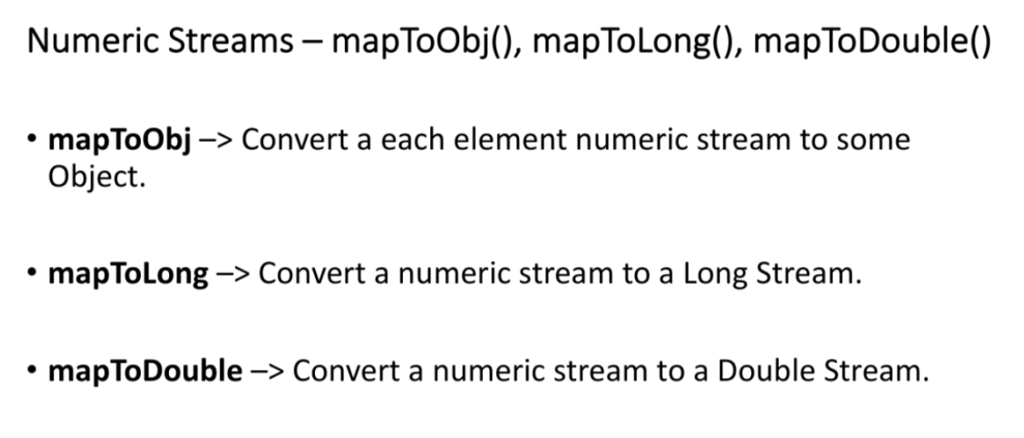

## Stream Terminal Operations:

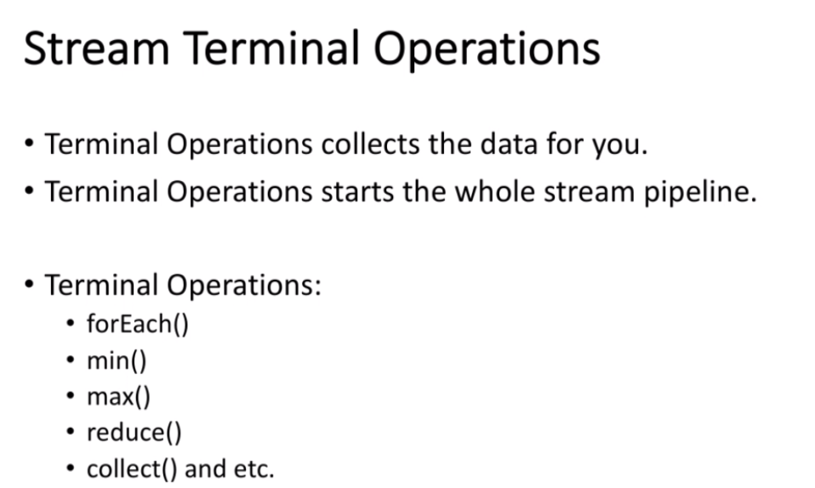

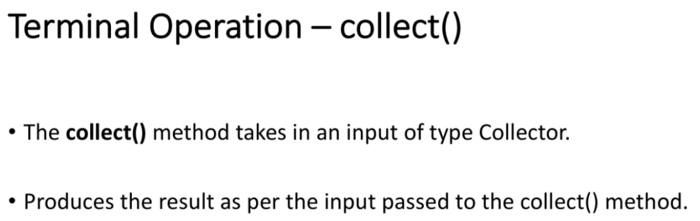

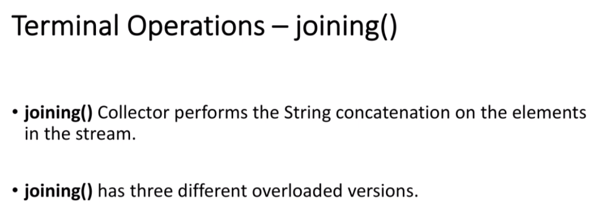

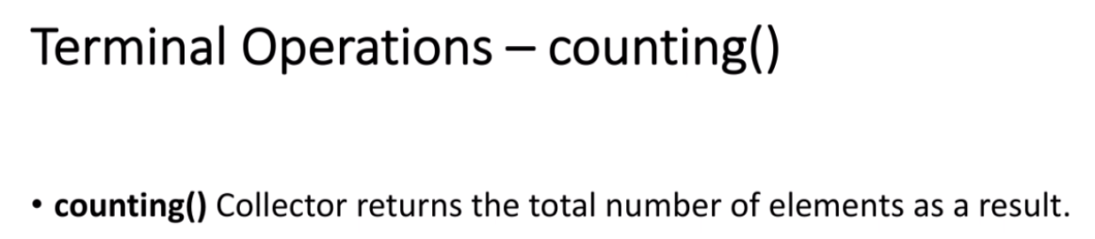

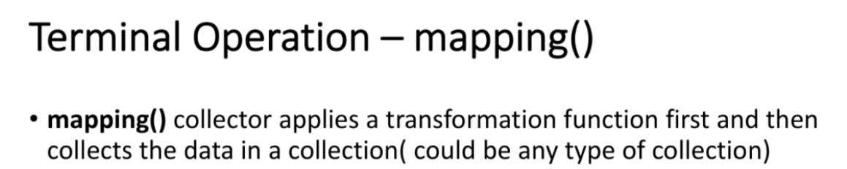

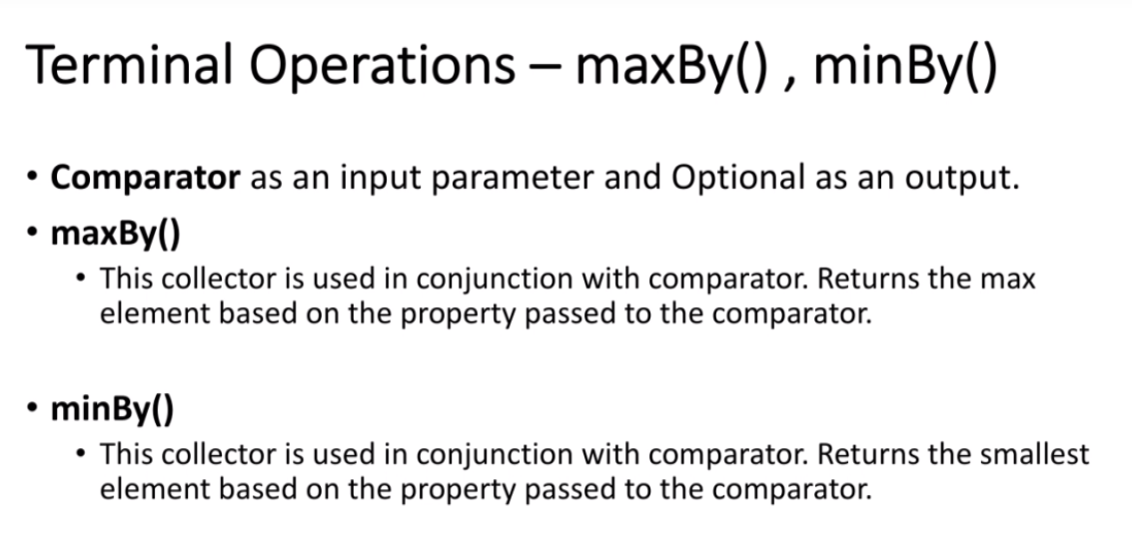

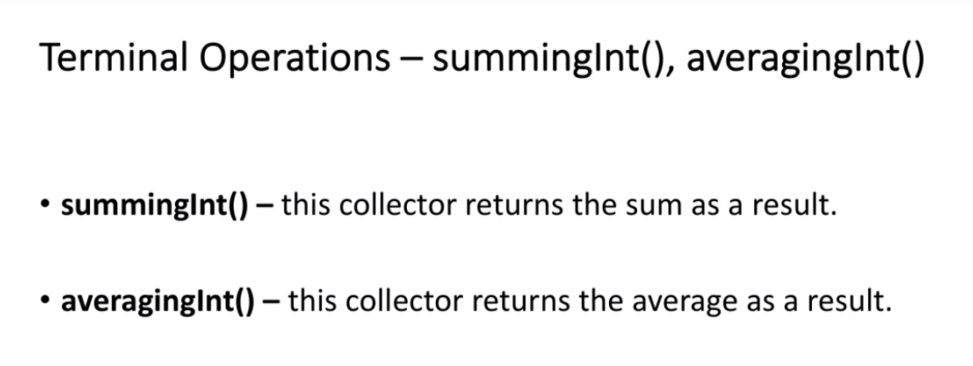

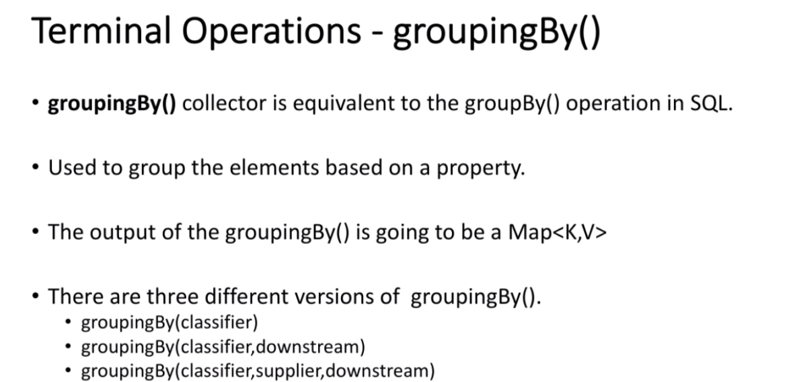

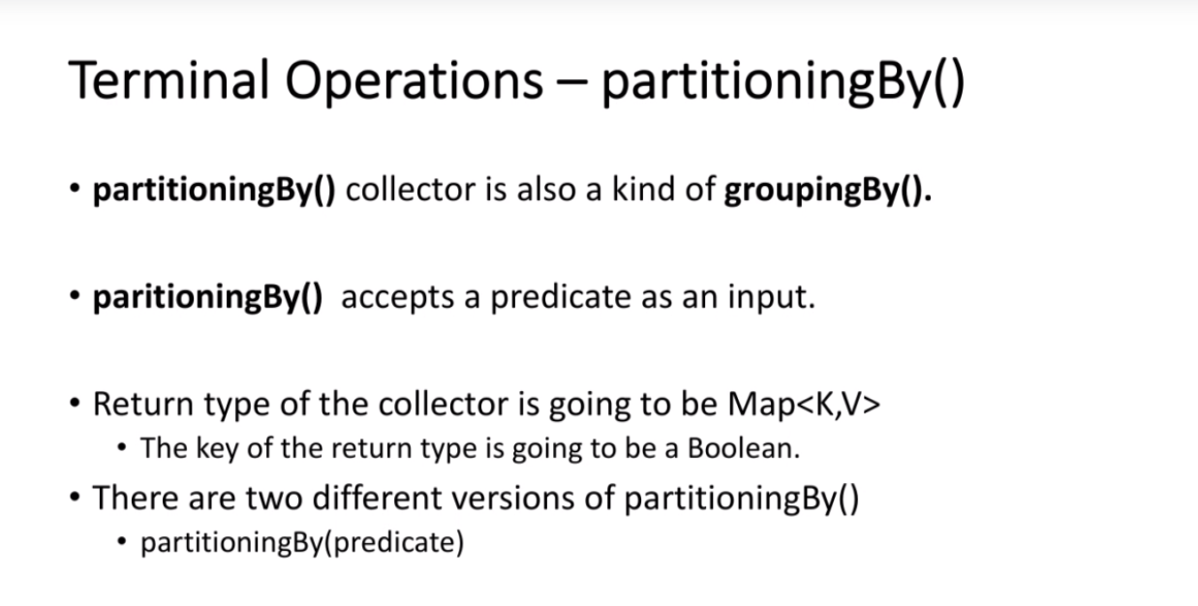

## Introduction to Parallel Streams:

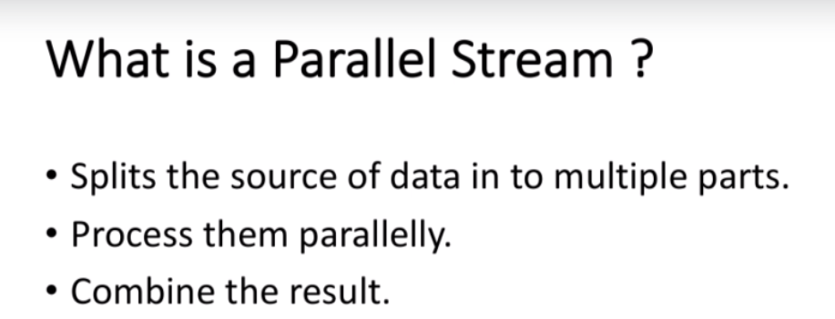

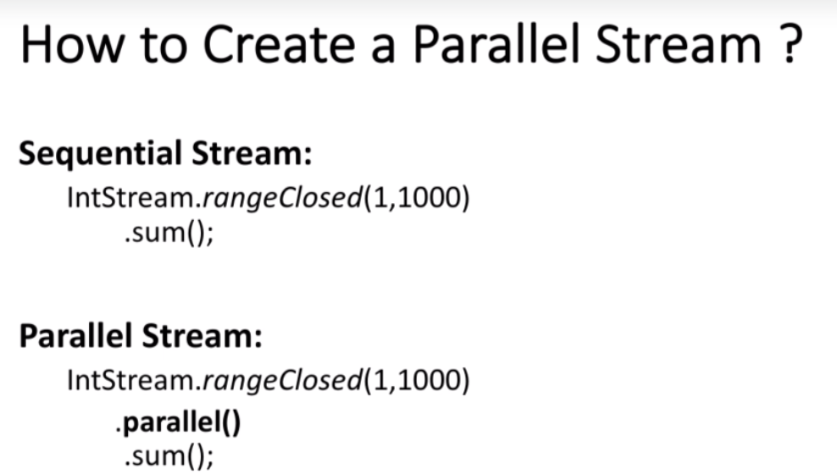

## Comparison of Sequential Vs Parallel Stream Performance:

Refer code.

### How Parallel Stream works:

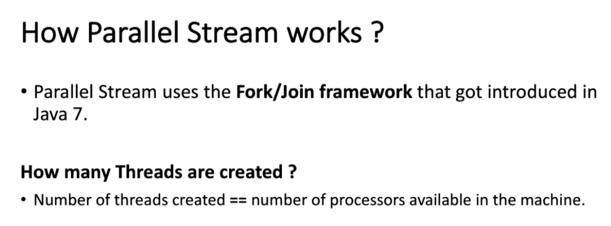

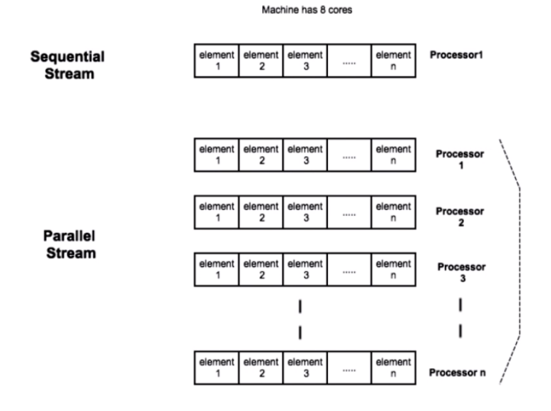

### When not to use parallel streams:

--when there is boxing,unboxing involved.

--when dealing with mutable variables.

## Optional:

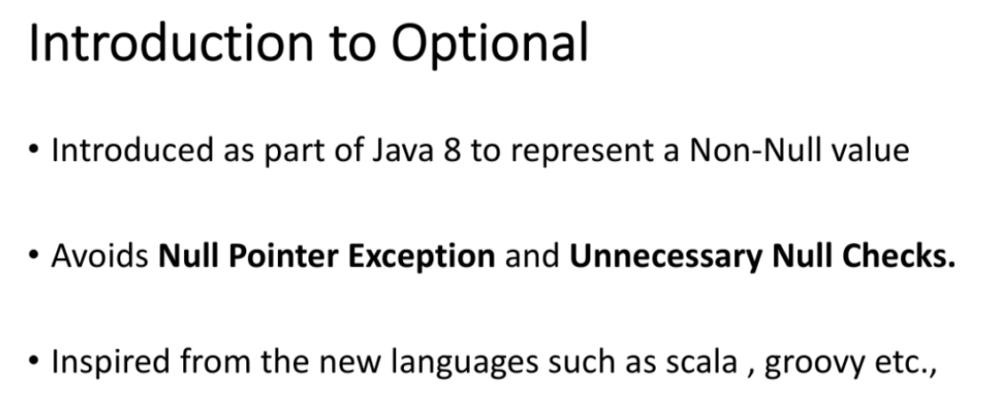

It always return an object,Optional, whereas null doesn’t have any datatype.

## Default/Static methods in Interfaces:

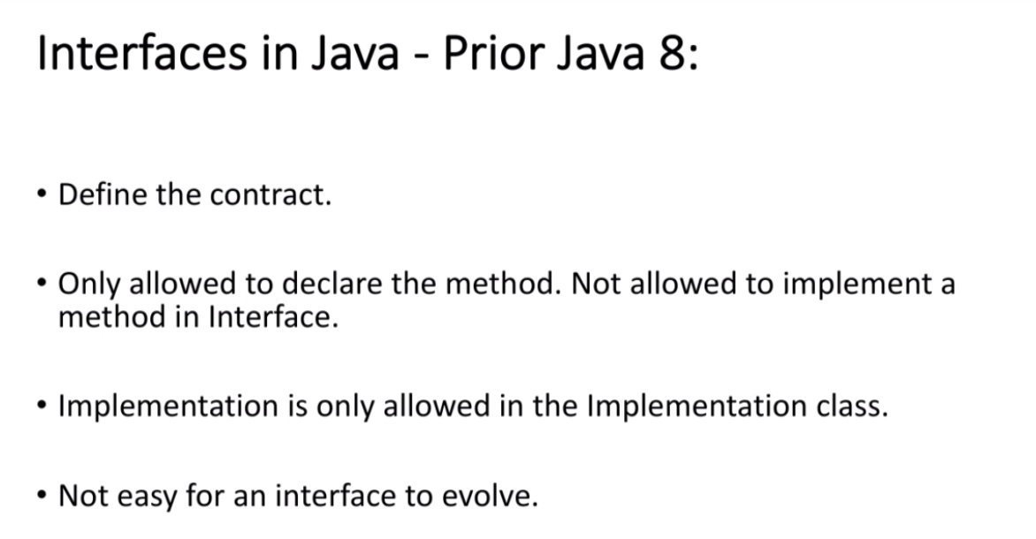

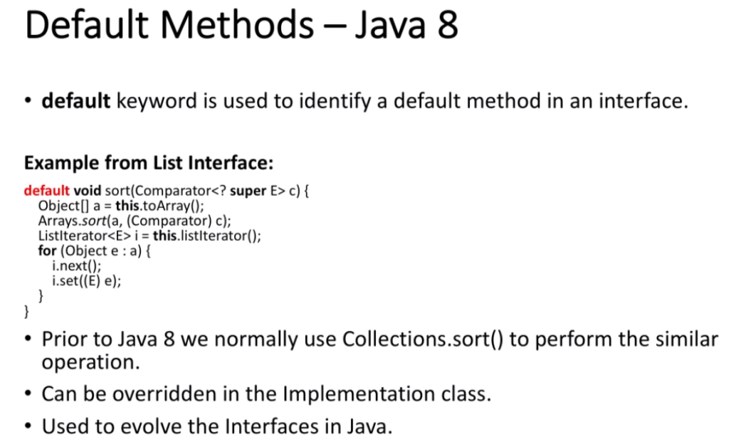

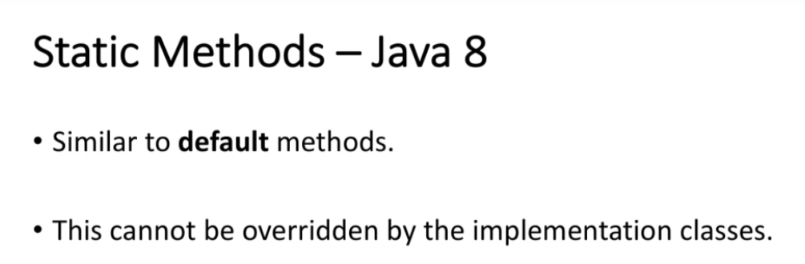

### Sort method:

Refer coding example.

### Create an Interface with Default methods:

Refer coding example. Default methods can be overridden whereas static method cannot.

## Abstract classes vs interfaces:

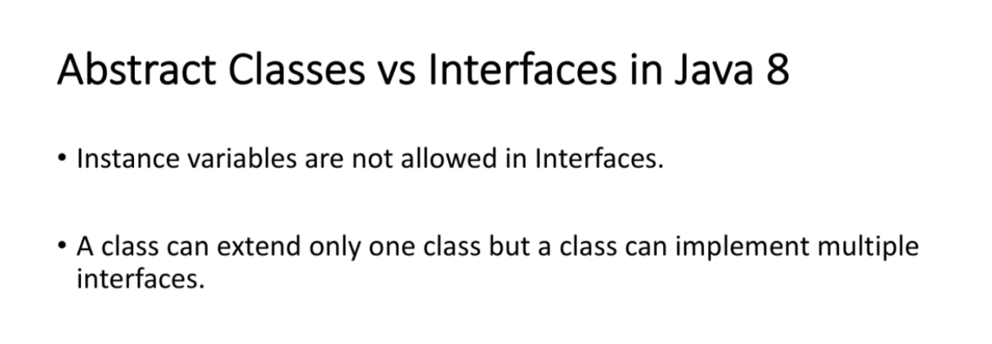

### Multiple Inheritance:

Multiple inheritance is made possible as one class can implement multiple interfaces and if methods are overridden child implementation takes the preference.

If same method exists in 2 interfaces then the method needs to be overridden in implementation class to resolve the multiple inheritance conflict issue.

## Introduction to New Date/Time Libraries:

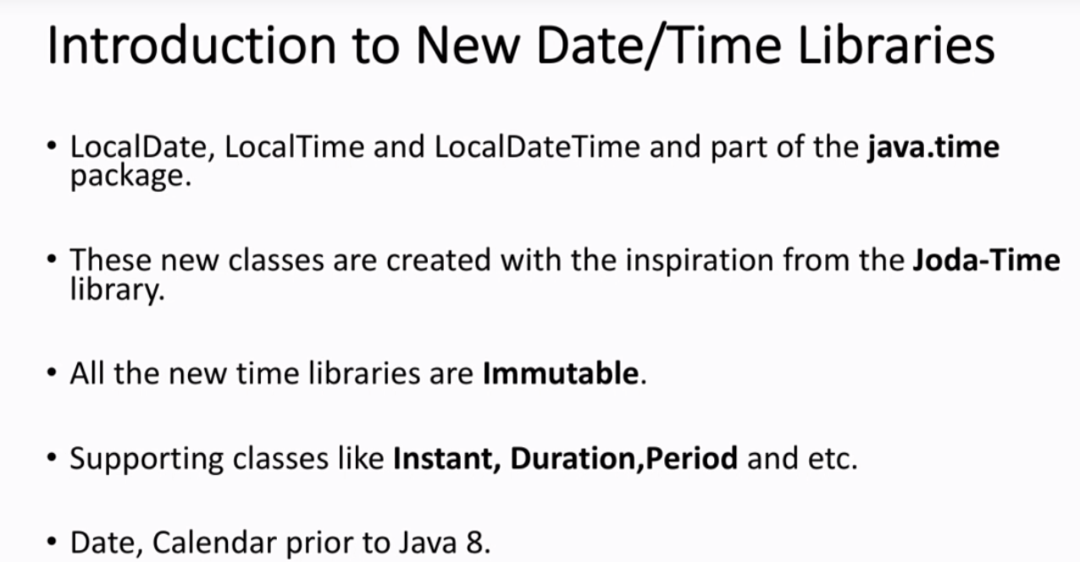

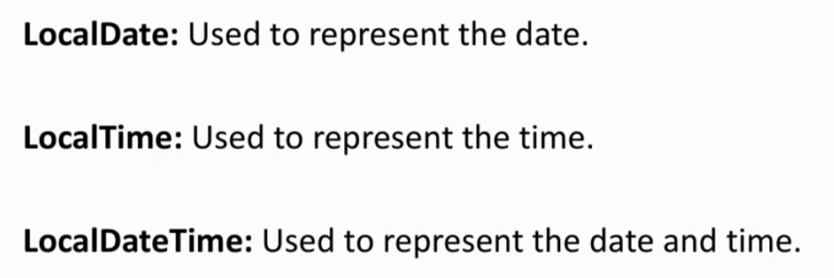

### Period:

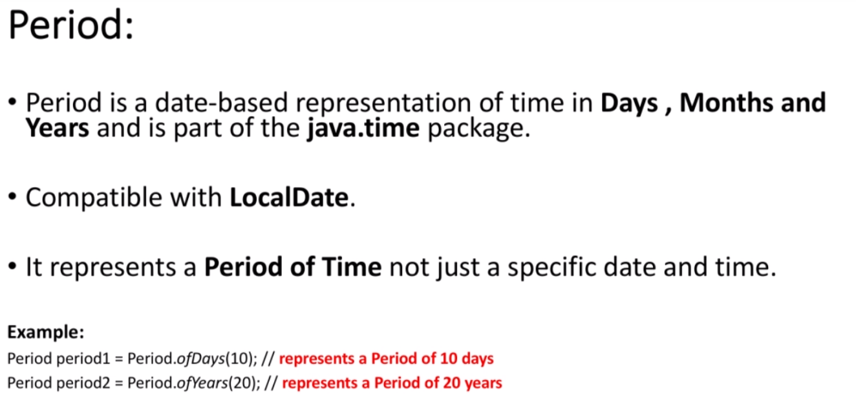

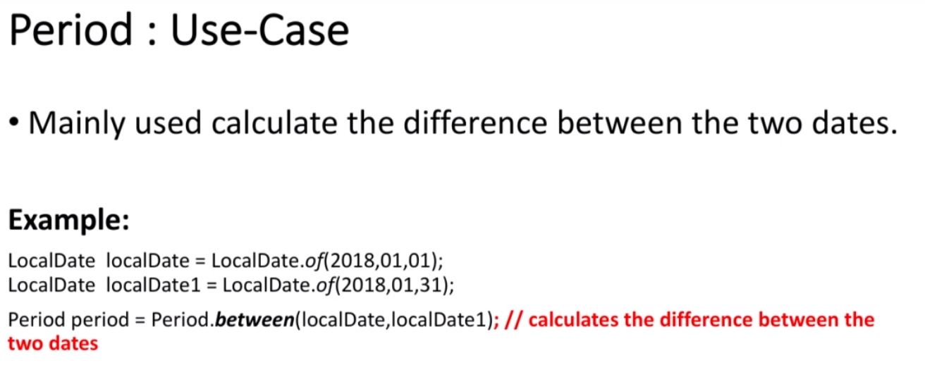

### Duration:

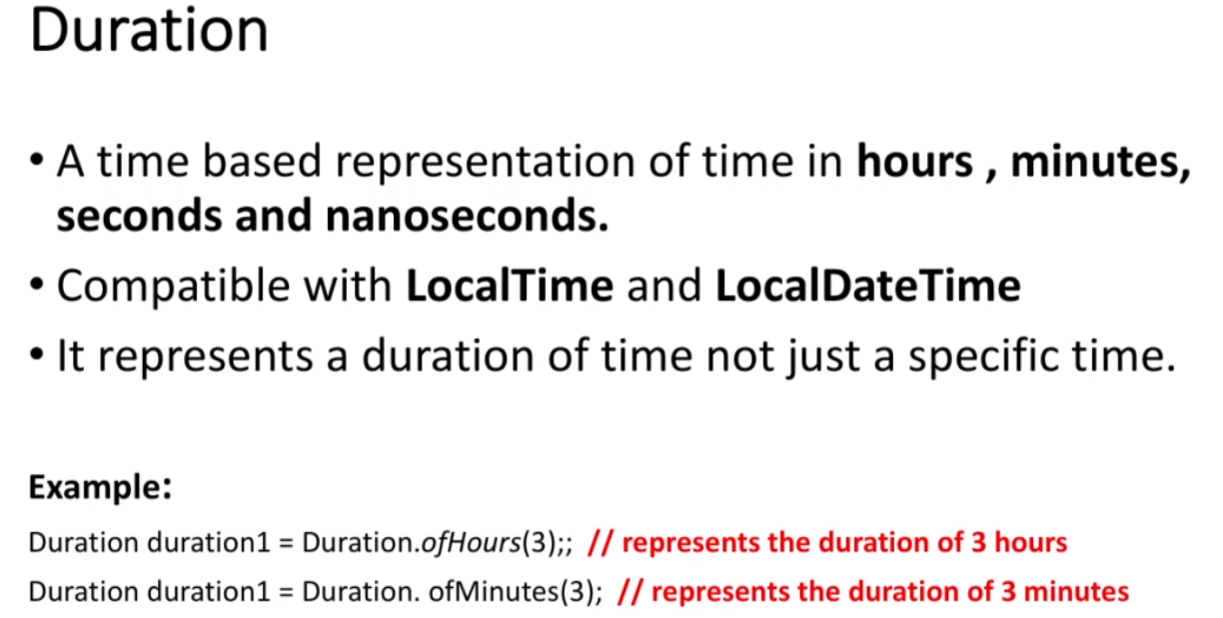

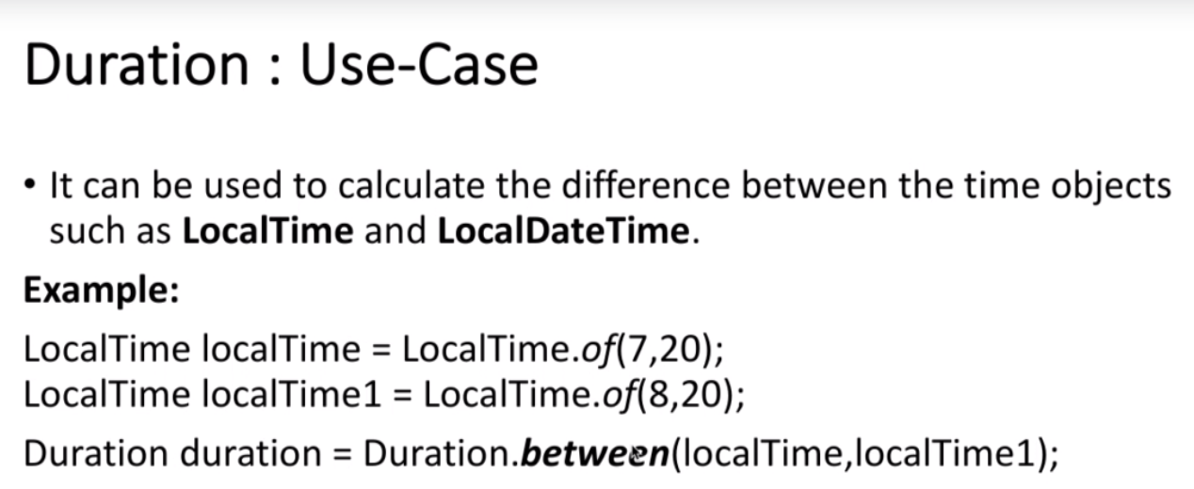

### Instant:

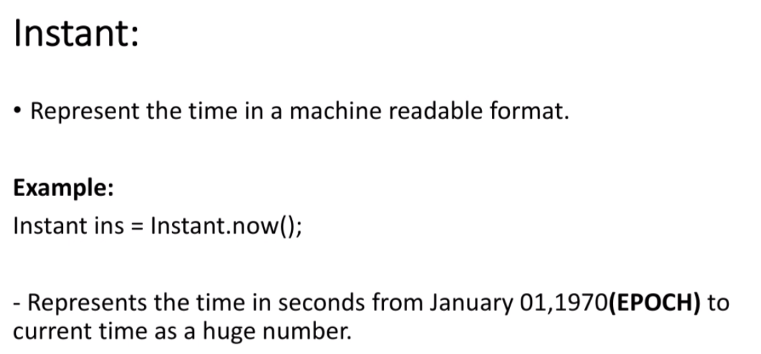

### TimeZones:

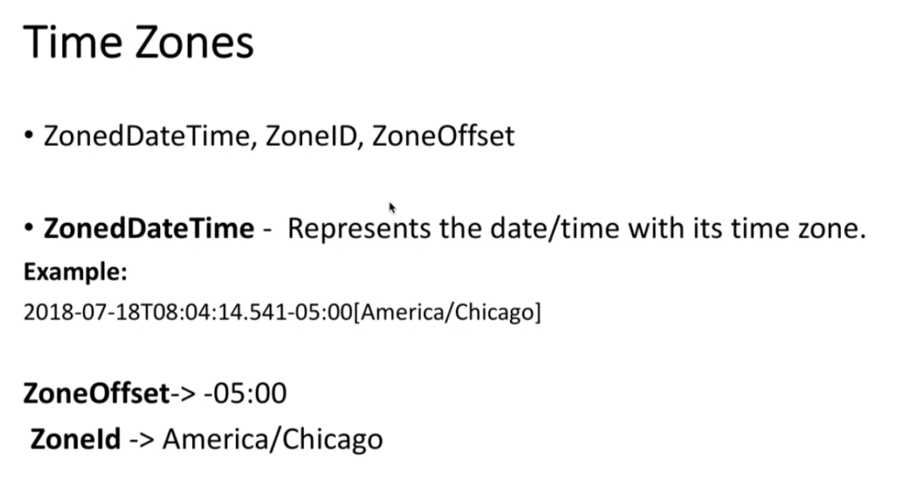

* Utilities to convert java.util.date/java.sql.date to LocalDate—check the code examples.

### DateTimeFormatter:

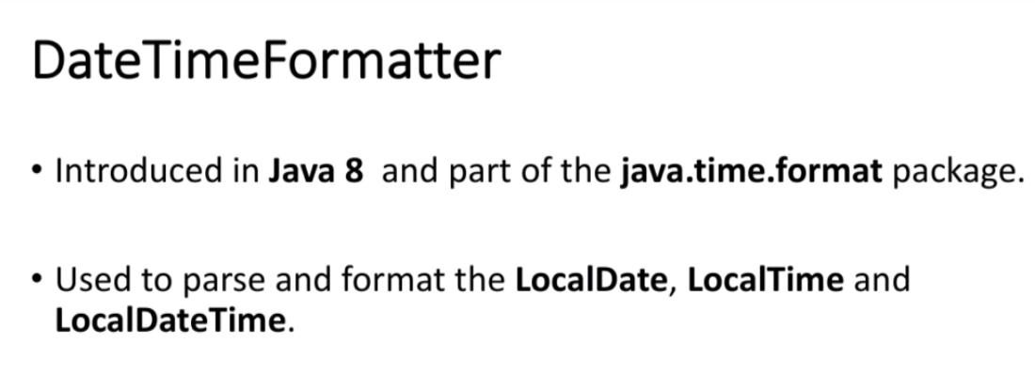

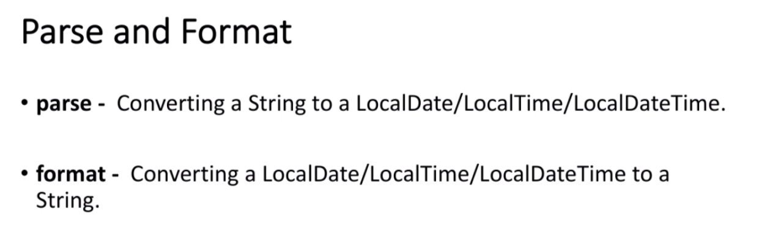

* There are some predefined formats supported like ISO_LOCAL_DATE(yyyy-mm-dd). Those can be re-used.

